CatchX Max
Bait boat
Quick start guide
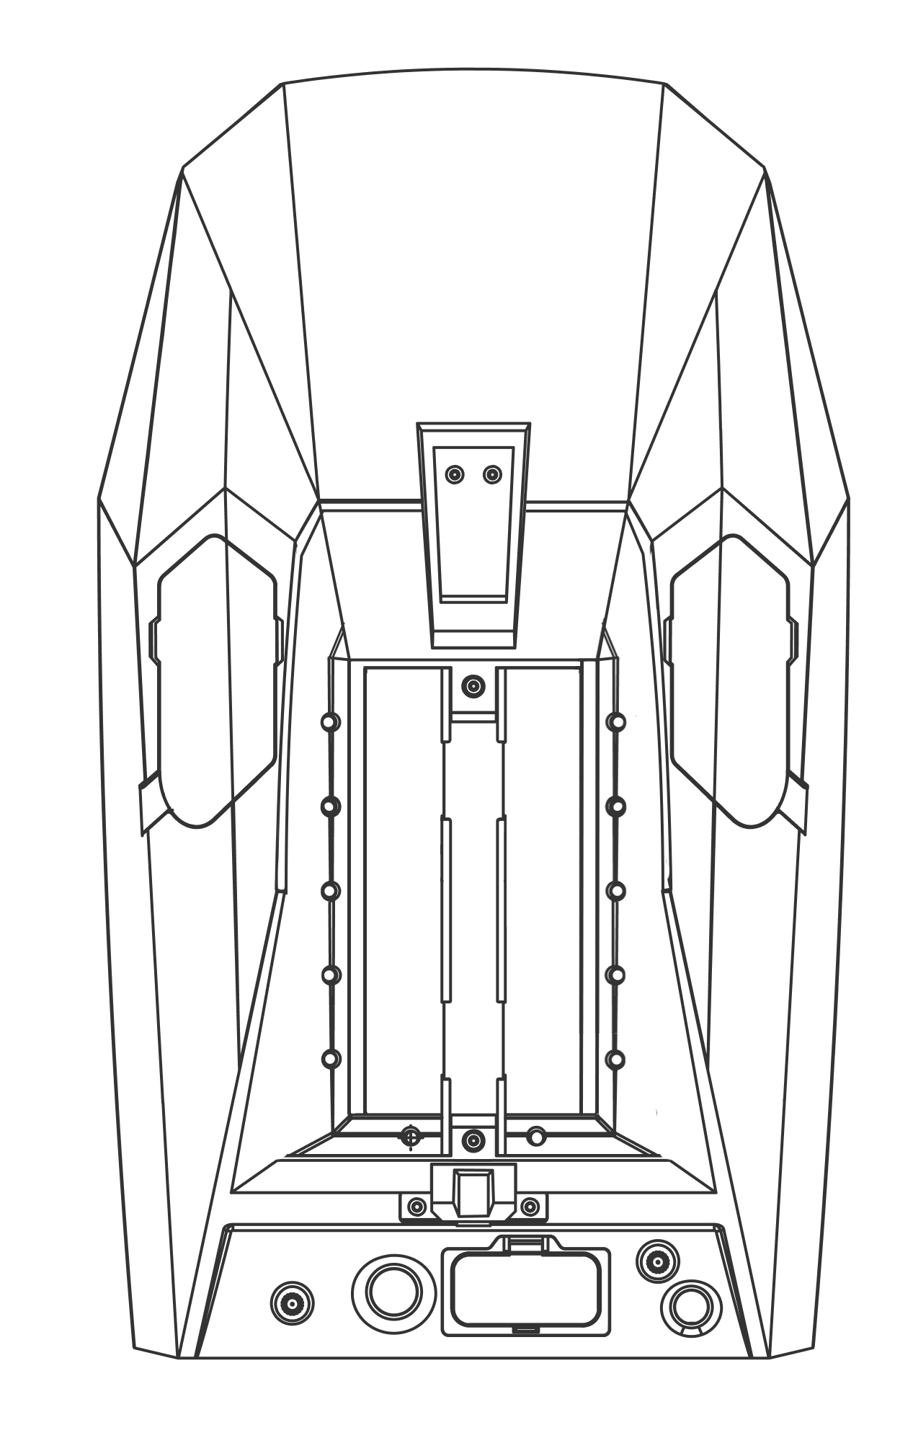

Introduction
Dear Customer,

Thank you for purchasing our product.

Before use, please download the "Rippton Boat" app on your mobile device.

How to Download the "Rippton Boat" App
Apple device users can search for "Rippton Boat" in the Apple App Store; Android device users can scan the QR code below to download and install the app on their mobile devices. The operating system requirements for installing the app are Android 6.0 or above and iOS 12.0 or above.
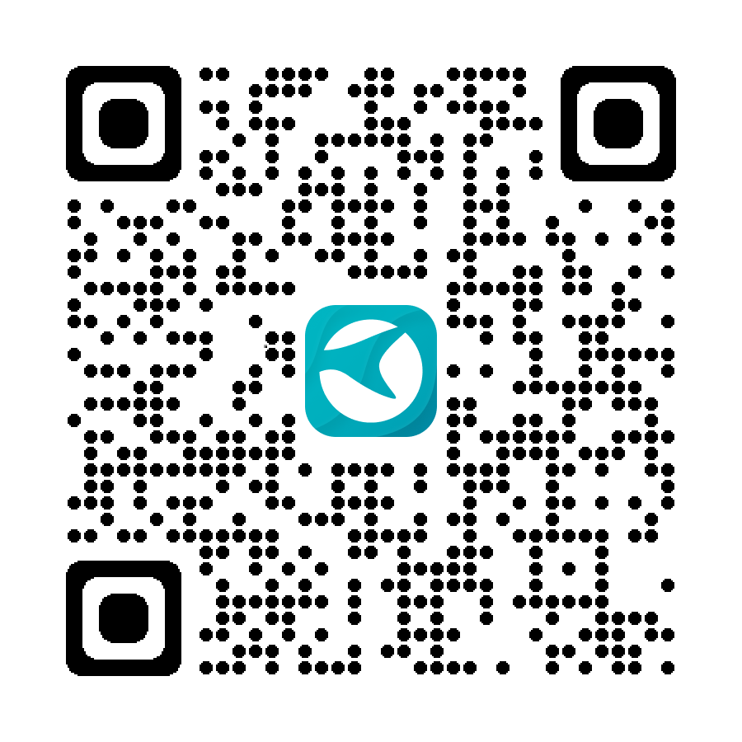

Friendly reminder: Images in this manual are for reference only and may differ from the actual product.
- Boat Overview
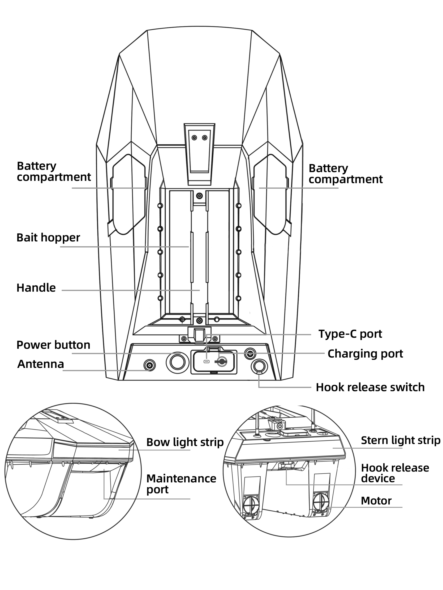
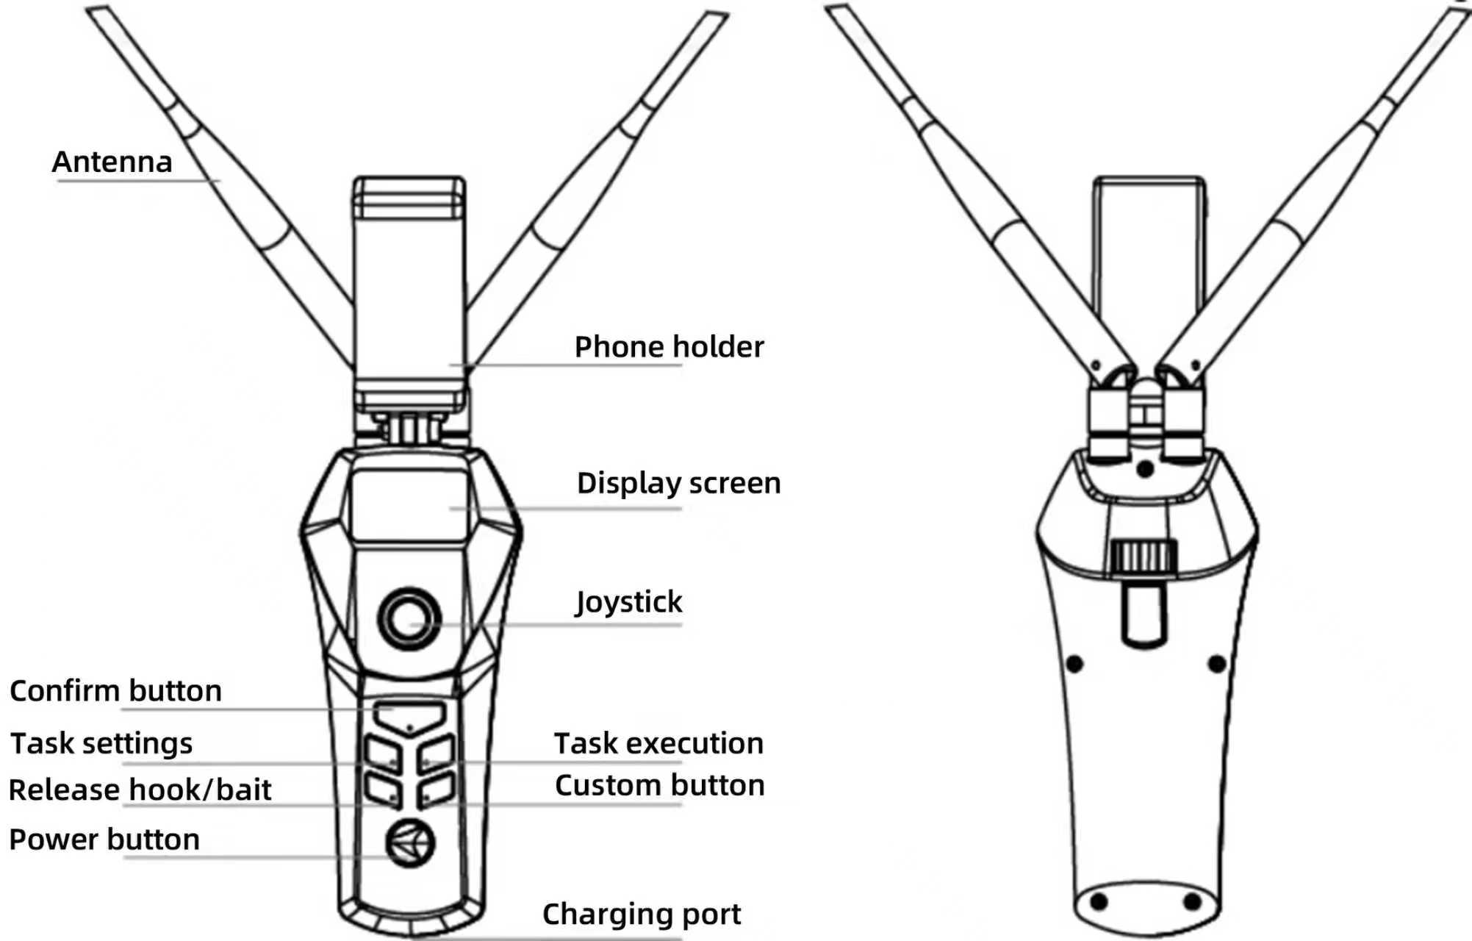
- Battery Installation
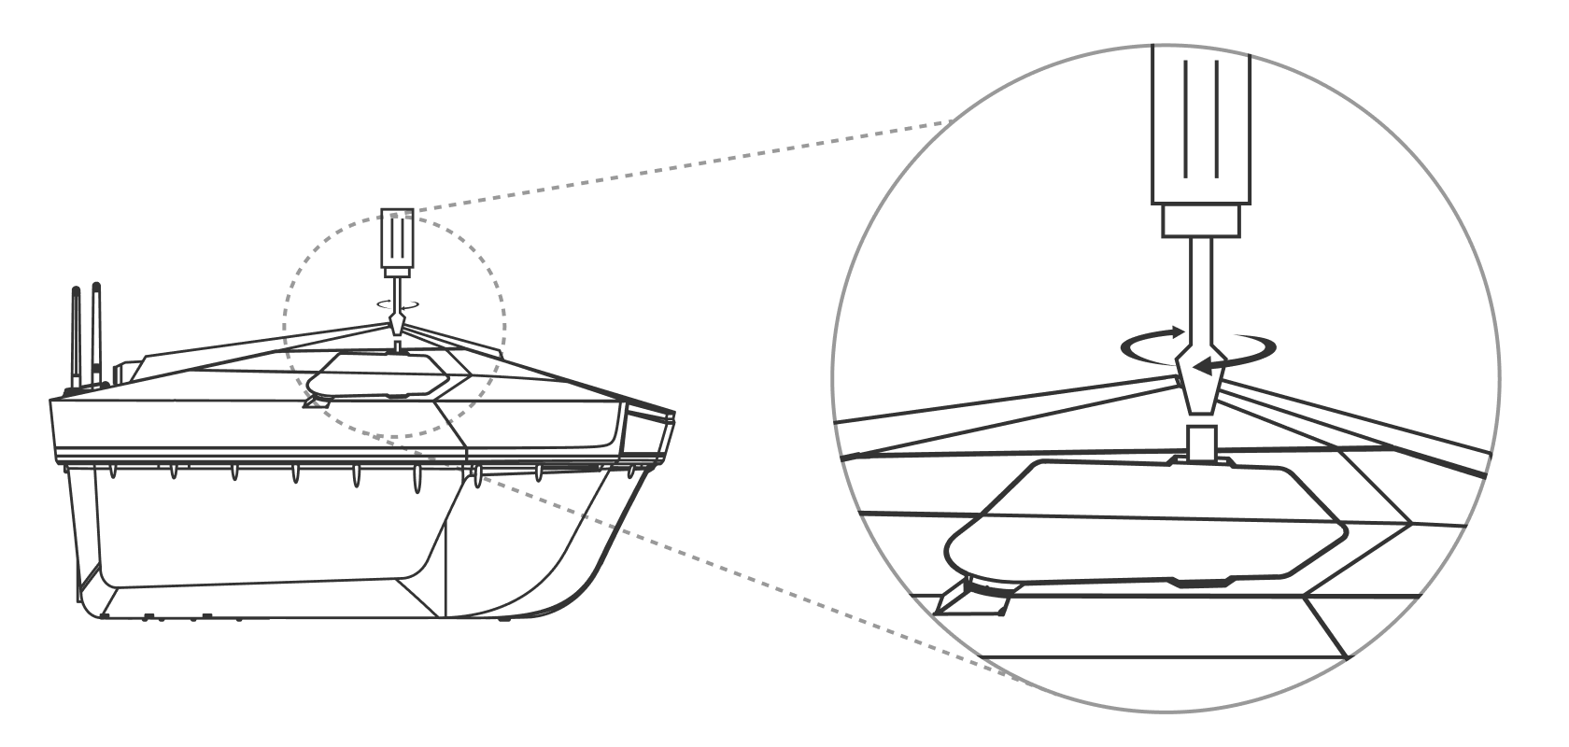
Unscrew the screws on the battery cover, connect the battery as shown in the left image, and then re-tighten the battery cover with the screws.

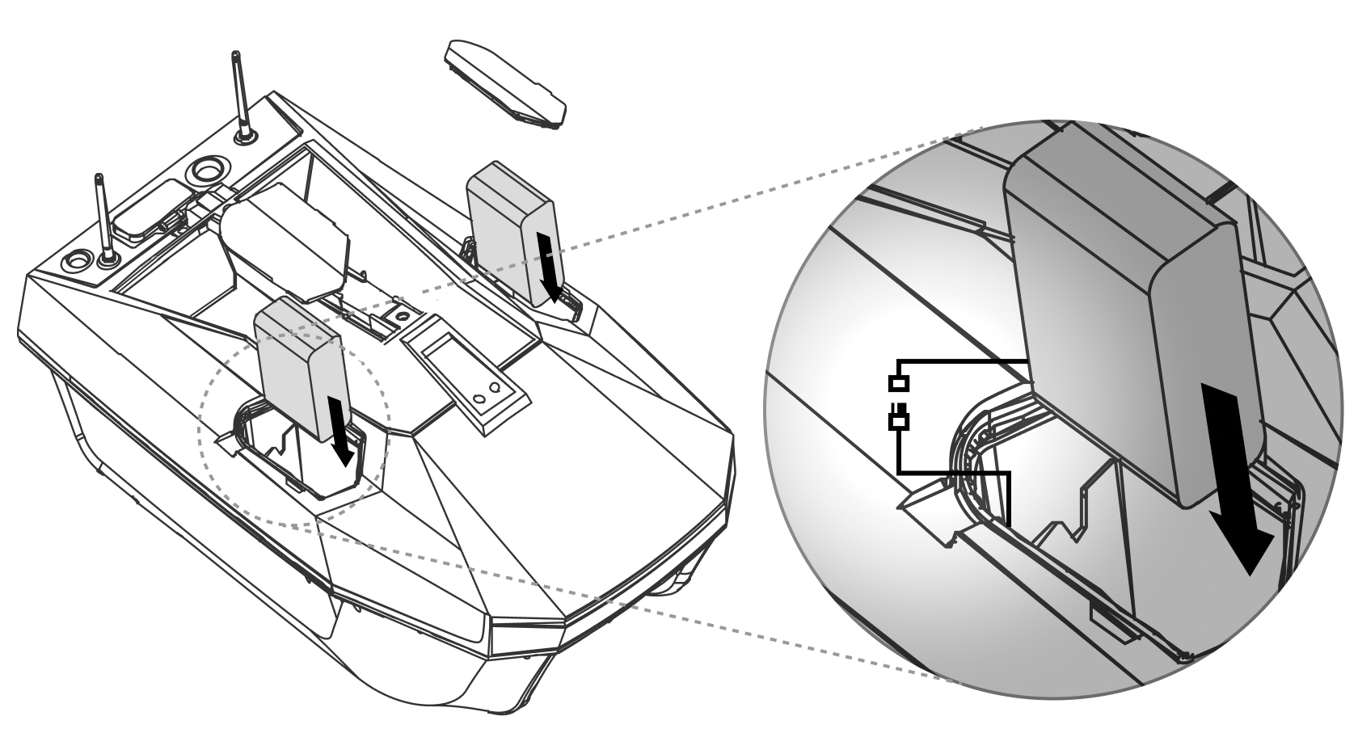

- Light Control
After turning on the handset and the boat, press the power button on the handset to turn on the boat’s bow light and stern light. Press it again to turn off the bow light and stern light.
- Hook Release Device
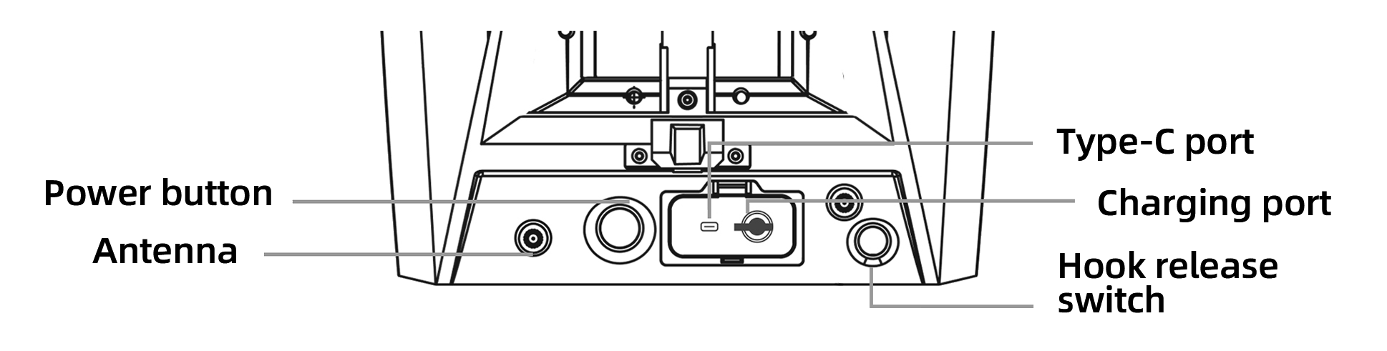
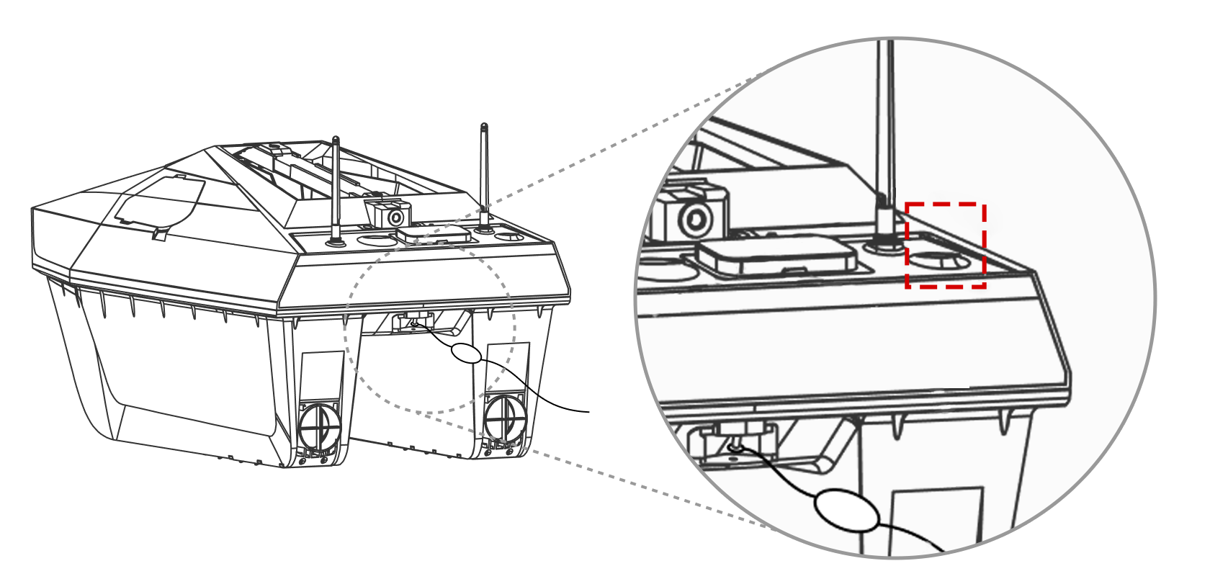
Press the button shown in the upper box to turn on the hook release switch, and release the button immediately to turn it off. If you keep holding the button, the switch will remain on for up to 3 seconds before automatically turning off. Attach the fishing line while the switch is on.

- How to Use the Handset
  - The handset itself is not waterproof, so please keep it away from water. When covered with the silicone case, it is splash-resistant. The handset will vibrate to alert you when the battery is low.
  - Kind reminder:Before operating your boat, please check the status bar at the top of the handset screen (as shown below). When the signal bar is full, the boat can be operated normally.



  - Handset preparation(The picture is for reference only and may differ from the actual product)
Step 1. Unfold the phone holder.  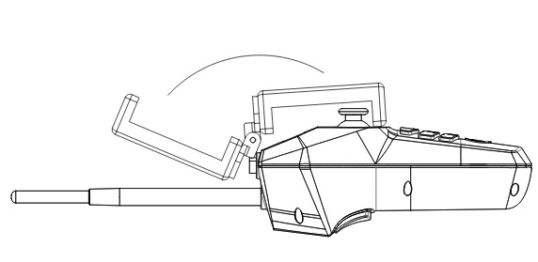 | Step 2. Install the antenna.  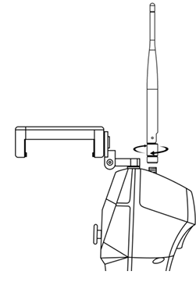
Step 3. Place the phone on the holder.
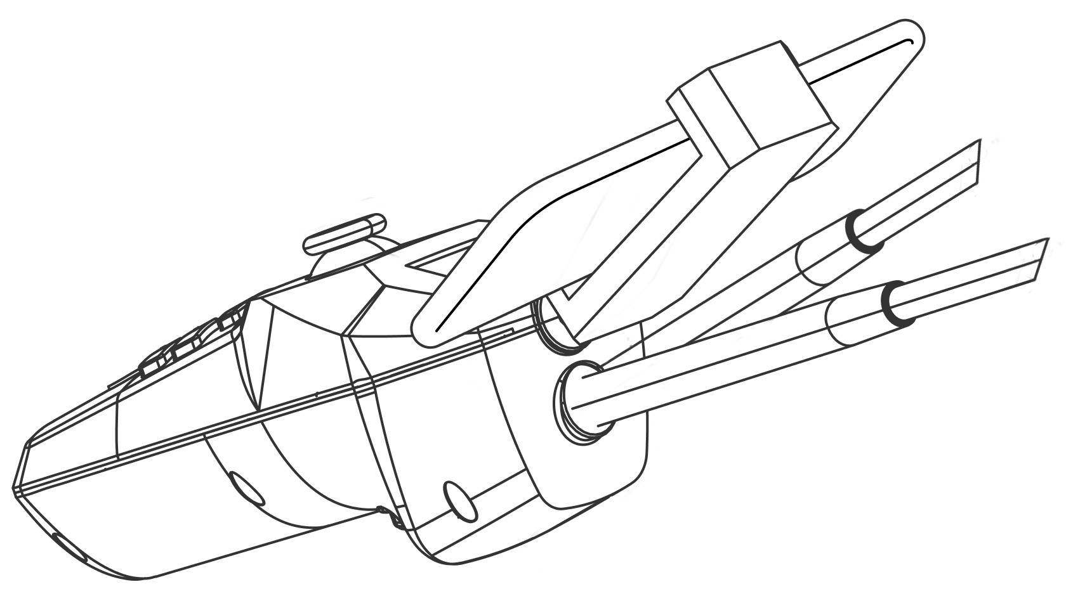
  - Basic joystick operations
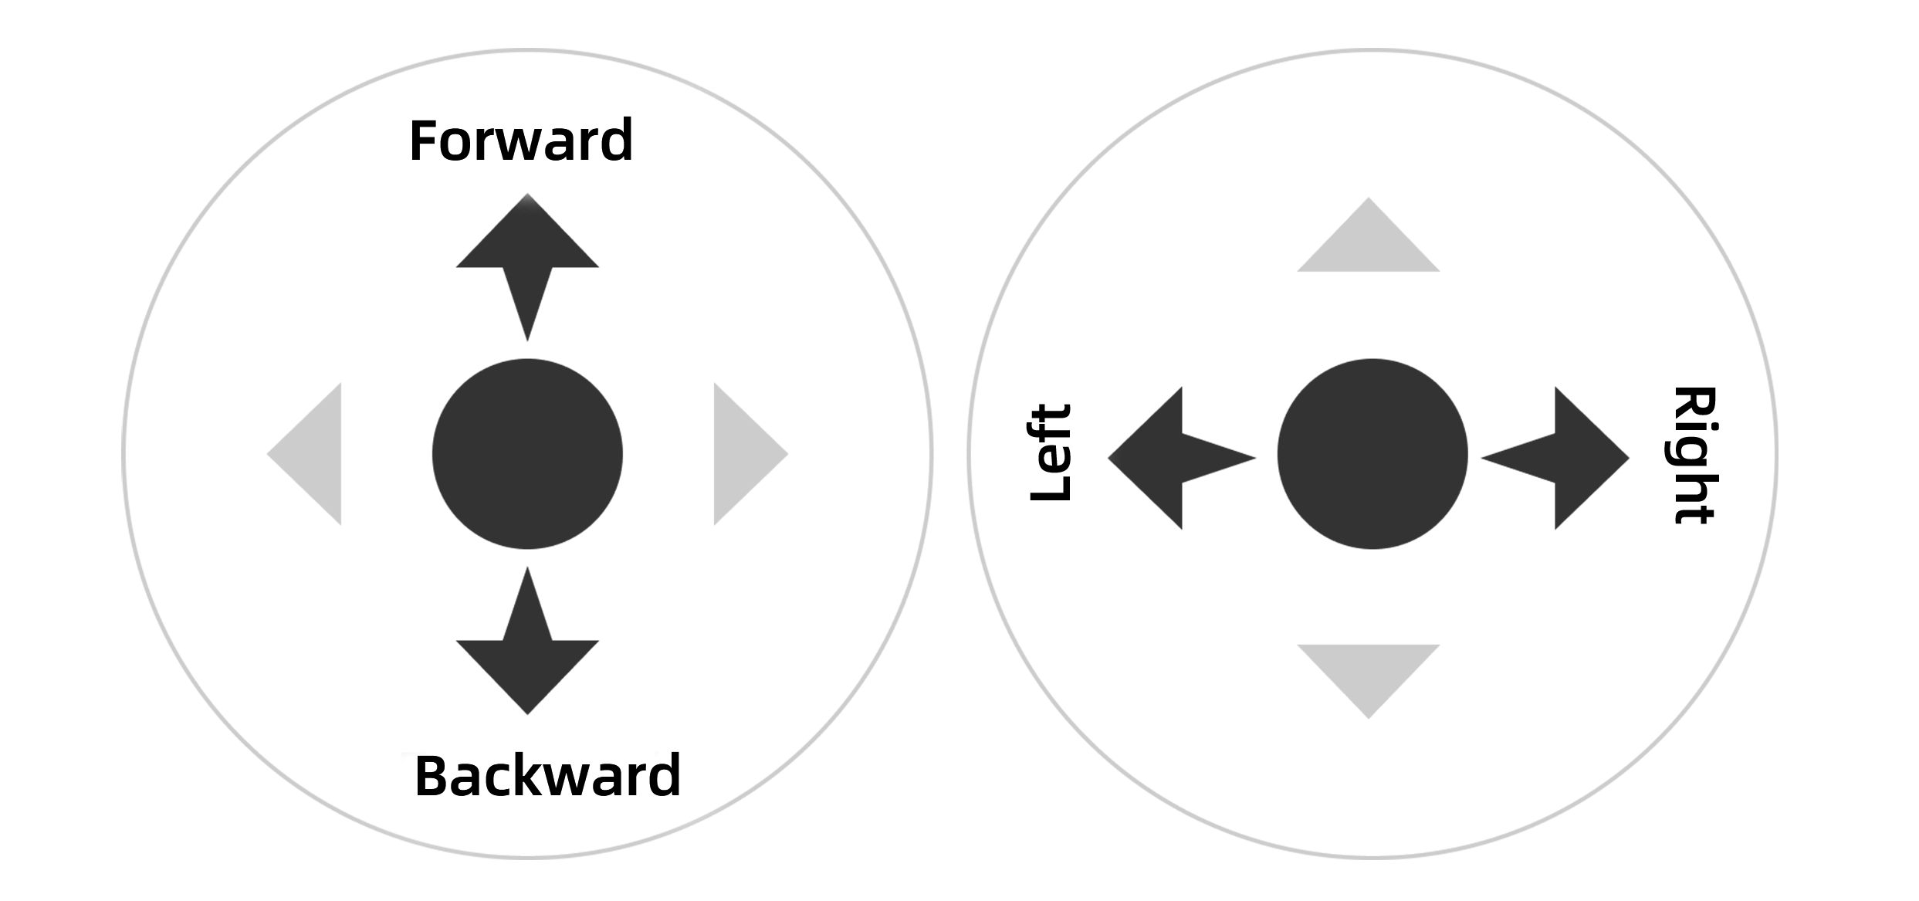
  - More usage tips
Scan the QR code to access the CatchX Max tutorial video


- How to Connect and Control the Bait Boat with Your Mobile Phone
Note: Before connecting to the bait boat, please load the map in the app first.

Before connecting the boat to your mobile device, please open the "Rippton Boat" app and enter the CatchX Max operation interface (see section 6.2 below) to complete preloading the fishing area map.
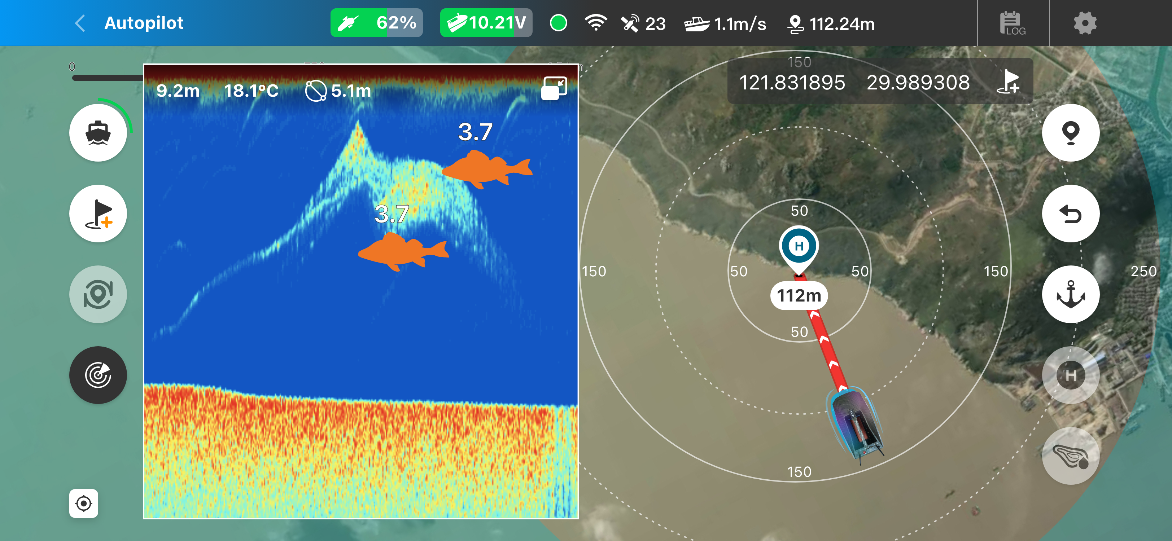

  - Connect the phone to the boat (handset and boat are powered on)
Step 1: Go to the wireless network settings and find the WiFi signal named RIP RC_******
Step 2: Select this WiFi and enter the password 12345678

After completing Step 2, you will temporarily lose your network connection.
  - Control
Open the "Rippton Boat" app and select the corresponding device.
Note: If the device name shows “CatchX Pro 2025,” click the arrow shown below to switch the version and change the device to “CatchX Max.”
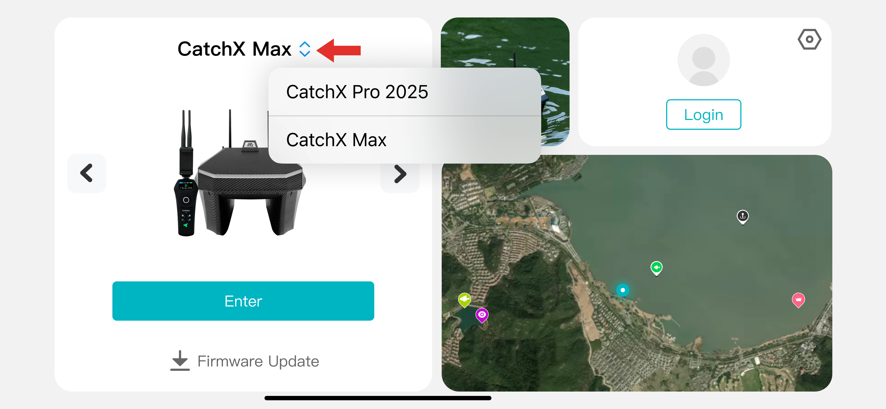
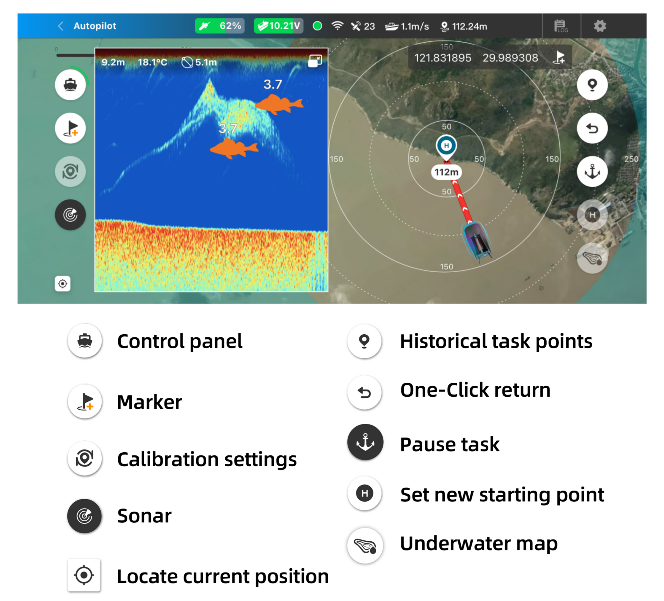

Scan the QR code to access the CatchX Max tutorial video
- Sonar Connection and Usage
CatchX Max is equipped with a built-in sonar. After connecting the bait boat to the Rippton Boat app, once the boat is placed in the water, the sonar data will automatically sync and display on the app.Scan the QR code to access the CatchX Max tutorial video.

- Charging
  - Bait boat charging method 1 and method 2
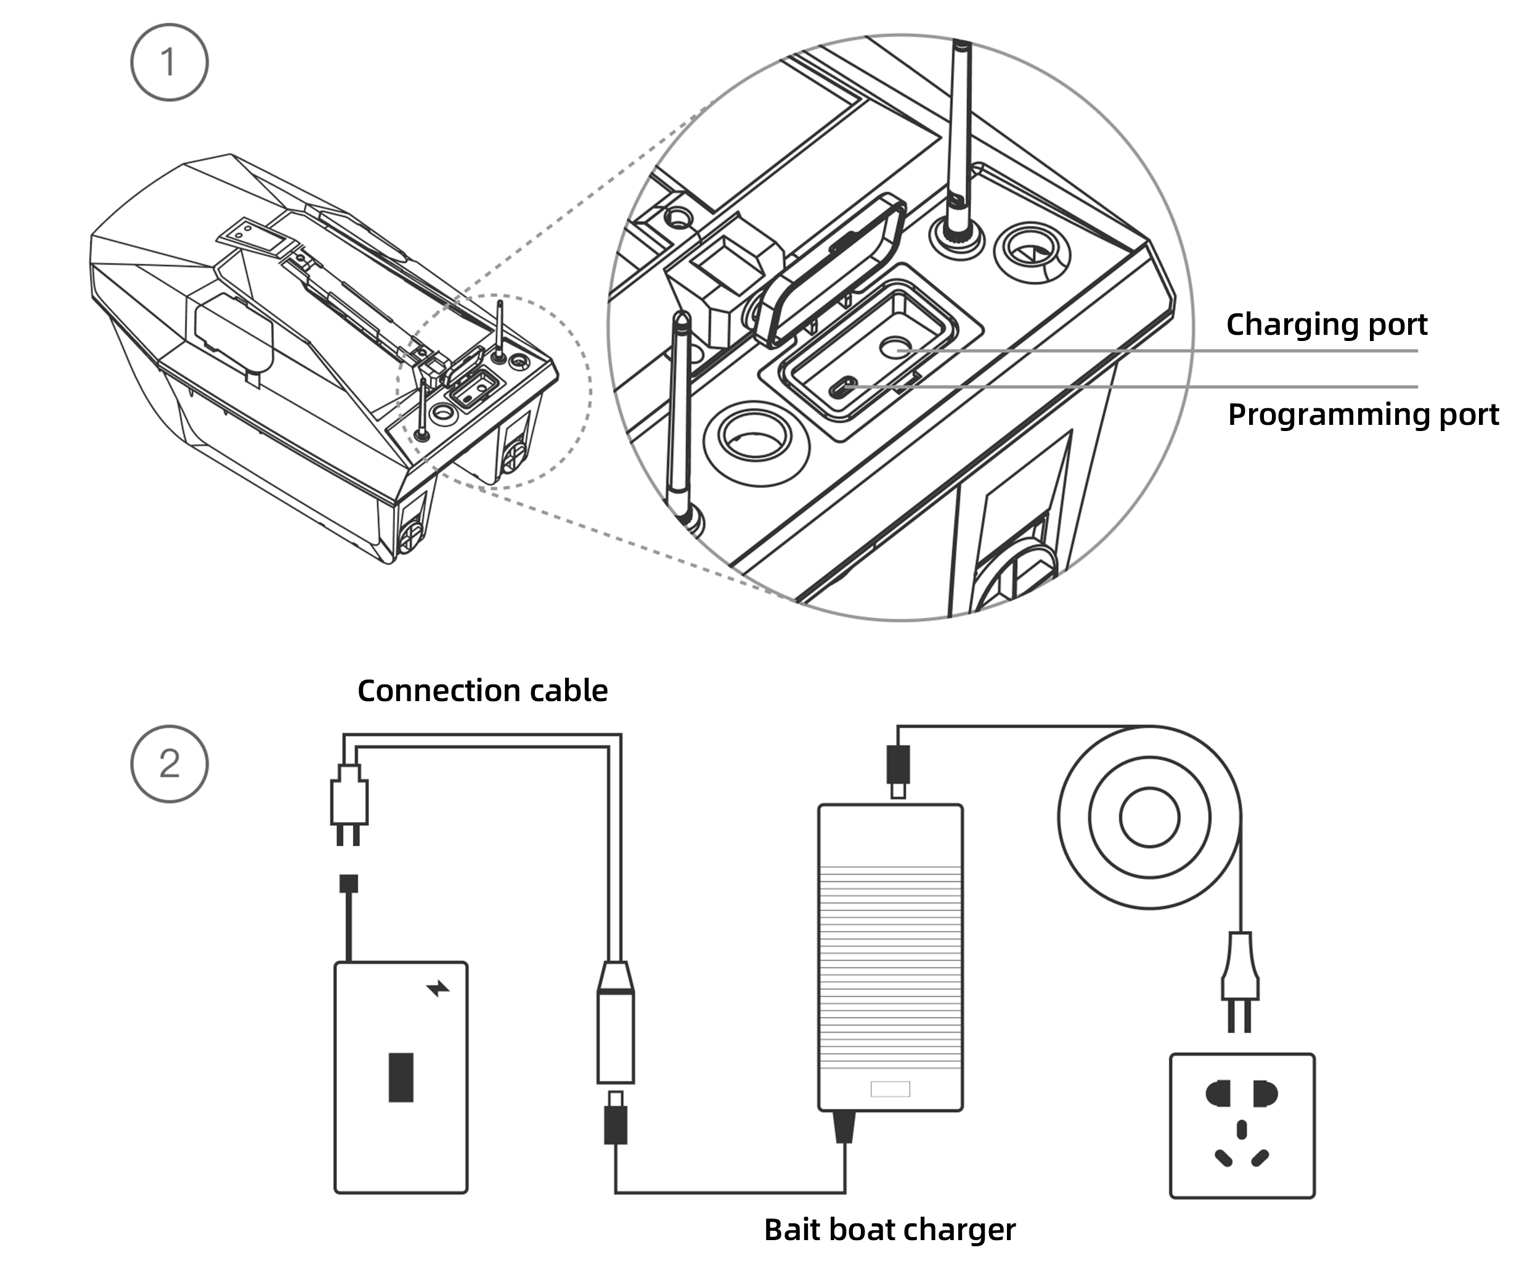
1: Charging inside the boat: Both batteries must be placed inside the boat before charging can begin;
2: Single charging: First, remove the batteries from the battery compartment, then connect the charger to the batteries as shown in the picture above. After charging is complete, place the batteries back into the battery compartment and connect them properly to the boat.
Charger indicator light | Charging status
Green | Charging complete
Red | Charging

Name | 12.6V lithium battery charger
Input | Input voltage | 100–240V AC
Input | Input frequency | 50/60 Hz
Input | Input current | Maximum 1.5A
Output | Output voltage | 12.6V DC
Output | Charging current | 5A
Output | Rated power | 63W
  - Handset charging
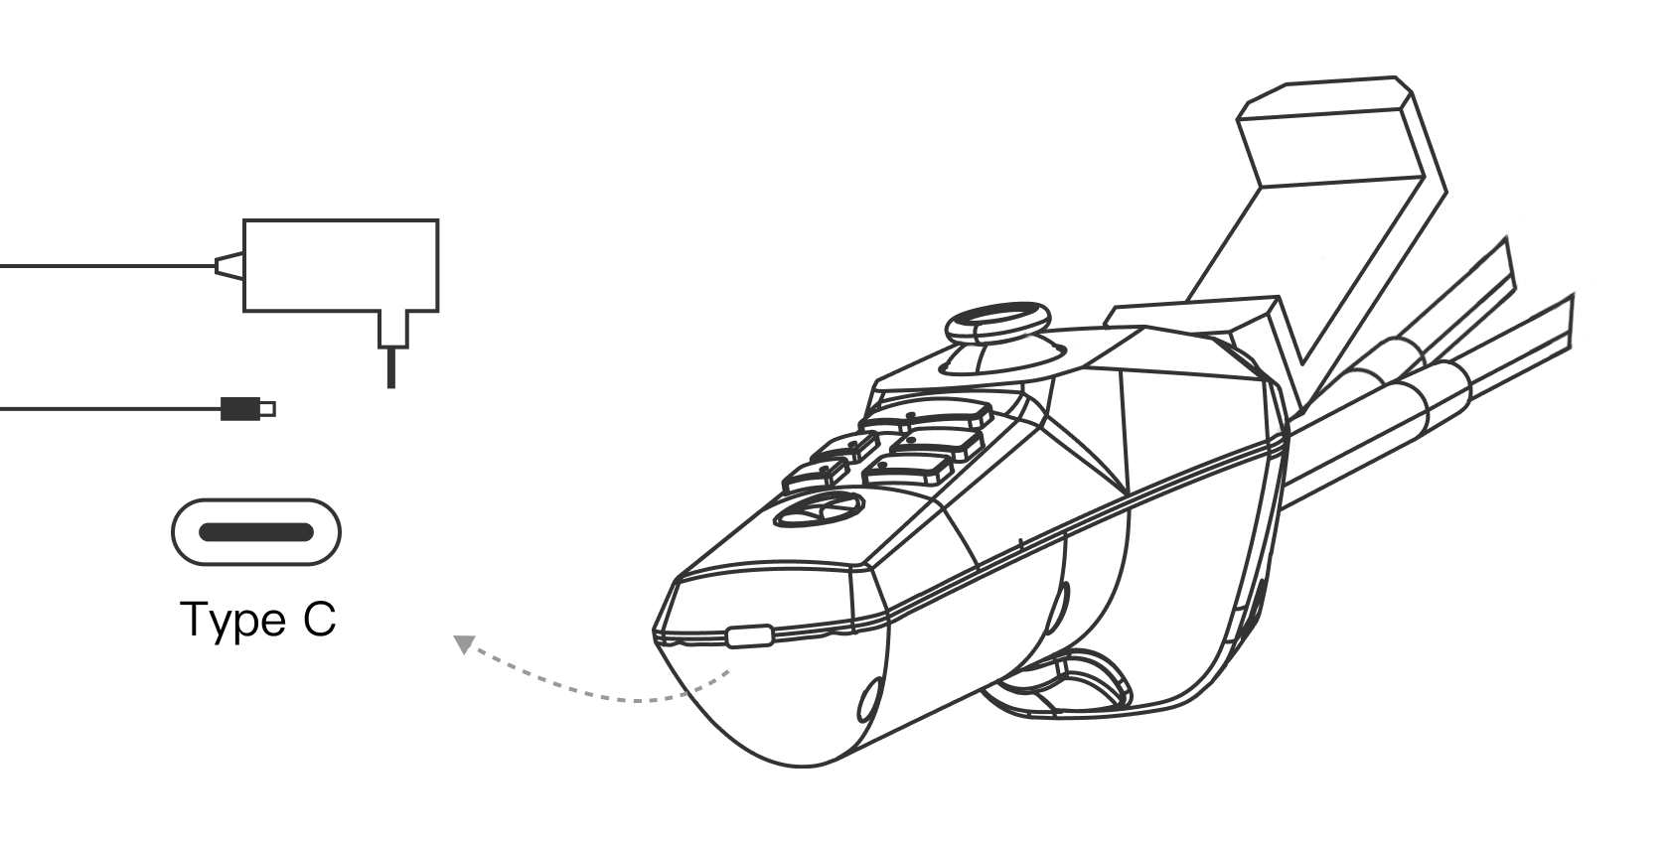
Name | 5V 3A charger
Input | Input voltage | 100–240V AC
Input | Input frequency | 50/60 Hz
Input | Input current | Maximum 1.0A
Output | Output voltage | 5V DC
Output | Charging current | 3A
Output | Rated power | 15W
  - Precautions
- Charger
- Operating temperature: 0℃~40℃
- Storage temperature: -20℃~80℃
- Complies with CE certification standards
- If the charger is damaged or has water ingress, stop using it immediately
- Battery
- When using the bait boat and handset for the first time, please fully charge the new batteries.
- Under normal conditions, it takes about 3–4 hours to fully charge the handset.
- Under normal conditions, when charging the bait boat batteries inside the boat, it takes about 4–6 hours to fully charge. Please ensure the bait boat power switch is turned off.
- When charging the bait boat batteries individually, it takes about 2–3 hours to fully charge one battery. Please fully charge both batteries before placing them back into the battery compartment. In all cases, the battery levels of the two batteries should be the same or only have slight differences.
- Battery Storage
- For long-term storage, make sure the bait boat and handset are off, and batteries are above 80% charge to prevent over-discharge.
- Store at -20℃ to 45℃ (up to 1 month).
- Charge batteries fully once a month to maintain battery life. Prolonged storage may harm batteries.
- Packing List
The product includes the following items and accessories:
- Quick start guide x 1
- Bait boat x 1
- Handset x 1
- Bait boat batteries x 2
- Bait boat chargers (built-in charging for batteries) x 2
- Handset charger x 1
- Battery single charging adapter cable x 2
Accessories may vary with different promotions and packages. Please refer to the purchase page for details.

- Specifications
Product name | CatchX Max Bait Boat
Weight | 6.3 kg (including batteries)
Dimensions | Length 61.5 cm × Width 35.8 cm × Height 29.3 cm
Number of bait hoppers  Hook release device | 1 hopper  Independent hook release device
Speed range | 0.5 - 1.1 m/s
Maximum load | 3 kg
Waterproof rating | Upper shell splash-resistant & lower shell fully waterproof
Lighting | One white bow light & one red stern light
Operating temperature | -10 ~ 45°C
Handset range | Approximately 400 m, may vary slightly due to weather conditions
APP range | 300m
Cruising time | About 3 - 4 hours
Standby time | About 30 hours
Handset
TFT screen size | 1.47 inches
Maximum transmission distance | 400 m
Battery
Type | Lithium battery pack
Capacity | 8000 mAh×2
Voltage | 12.6 V
- Usage Recommendations
- App updates: Please update promptly via the relevant app store according to system notifications.
- Always ensure both the handset and the boat are powered on and successfully connected before launching the boat. This guarantees you maintain full control.
- Always prevent the handset from getting wet.
- When not in use, store the boat and handset in a warm, dry place to avoid moisture condensation.
- It is recommended to clean the bait boat with a damp cloth after use.
- After use, make sure all batteries are fully charged before storing the boat for next time.
- If the boat will not be used for several months, charge the batteries monthly.
- The distance between any two task points you select should be more than 5 meters.
- Due to water currents, surrounding buildings, environmental factors, and changes in GPS satellites over time, the actual boat position may deviate by about 1.5 to 2 meters.
- The boat’s range depends on weather and environmental conditions.
- This boat’s operation methods described in this manual may change due to firmware or app upgrades.For more details, refer to Rippton’s official YouTube channel @ripptonsmartfishing.

Warranty

We offer you a 12-month guarantee from the date of purchase.

The guarantee covers any defects arising from the drive unit and the electrical and electronic parts of the boat, faulty material or workmanship.

It does not cover batteries, damage arising from improper use, breakage, or normal wear of the boat or associated equipment.

The guarantee is invalidated if repairs or modifications are undertaken by unauthorized persons.

The guarantee period for the rechargeable battery and the rechargeable LI-ION batteries is 6 months from the date of purchase.


Name: Sea&Mew Accounting Ltd
Address: Electric Avenue Vision 25, London, Enfield EN3 7GD
Contact Person: Billy Han
Email: info@seamew.net


Name: Sea&Mew Consulting GmbH
Address: Mittenhuber Straße 4, 92318 Neumarkt
Contact Person: Yuan Li
Email: Compliance.EU@outlook.com

Manufacturer & Importer

Company Name: Ningbo Pelican Smart Fishing Tackle Co., Ltd
Address:16 Yongchang Road, Xiangshan County, Ningbo, Zhejiang Province, China, 315000
Email for support: support@rippton.com or business@rippton.com

Made in China

